TITANIC PASSENGER DATASET
Week 3: Statistical Hypothesis Testing, Predictive Modeling, Diagnostics & ROC Analysis Report

1. Executive Summary & Objective
This report documents the complete Week 3 statistical analysis and predictive modeling workflow performed in R on the Titanic passenger dataset. It includes the dataset rationale, hypothesis testing, normality assumption checks, logistic regression model development, cross-validation, residual diagnostics, confusion matrix evaluation, and ROC/AUC performance analysis, along with console outputs and screenshots captured directly from Posit Cloud.

2. Dataset Selection & Rationale
The Titanic passenger dataset was selected for this task because it is a well-documented, publicly available dataset that is well suited to binary classification. It contains a mix of categorical predictors (passenger class, sex, cabin availability) and continuous predictors (age, fare), along with a clearly defined binary outcome variable, Survived. This combination makes it ideal for demonstrating hypothesis testing, assumption checking, and logistic regression modeling within a single, interpretable workflow, while the dataset's size (891 records) is large enough to support a meaningful train/test split and k-fold cross-validation.

3. Step 1: Hypothesis Testing (Chi-Square & t-Test)

R Code Executed
library(dplyr)

chisq_result <- chisq.test(table(df$Pclass, df$Survived))
print(chisq_result)

t_test_result <- t.test(Fare ~ Survived, data = df)
print(t_test_result)

Console Output
Pearson's Chi-squared test
data: table(df$Pclass, df$Survived)
X-squared = 102.89, df = 2, p-value < 2.2e-16

Welch Two Sample t-test
data: Fare by Survived
t = -6.8391, df = 436.7, p-value = 2.699e-11
alternative hypothesis: true difference in means between group 0 and group 1 is not equal to 0
95 percent confidence interval: -33.82912 -18.72592
sample estimates:
mean in group 0 (Non-Survivor): 22.11789 | mean in group 1 (Survivor): 48.39541
Interpretation: The chi-square test shows a highly significant association between passenger class and survival (p < 2.2e-16), and the Welch t-test shows a highly significant difference in mean fare between survivors and non-survivors (p = 2.7e-11), with survivors having paid substantially higher average fares. Both results justify including Pclass and Fare-derived variables as predictors in the classification model.

4. Step 2: Normality & Distribution Assumption Checks
Before modeling, the Shapiro-Wilk test was used to assess whether the continuous predictors Fare and Age follow a normal distribution, since violations of normality affect the validity of parametric tests such as the t-test used above.

R Code Executed
shapiro.test(df$Fare)
shapiro.test(df$Age)
qqnorm(df$Fare); qqline(df$Fare)

Console Output
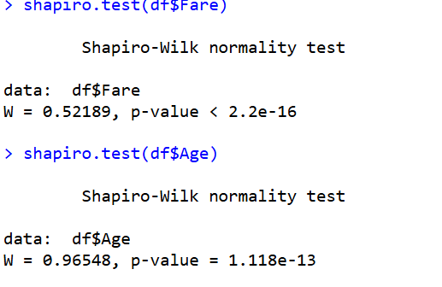
Figure 1. Shapiro-Wilk normality test results for Fare and Age.

Q-Q Plot: Fare
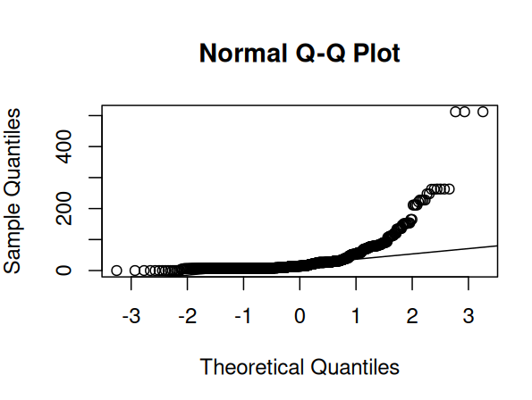
Figure 2. Normal Q-Q plot of Fare, showing strong right-skew and heavy departure from normality in the upper quantiles.
Interpretation: Both variables reject the null hypothesis of normality (Fare: W = 0.522, p < 2.2e-16; Age: W = 0.965, p = 1.12e-13). The Q-Q plot for Fare confirms a strongly right-skewed distribution with a long tail of high-fare passengers. This is expected for real-world fare data and is why the Welch t-test (which does not assume equal variances) was used above, and why Fare and Age were normalized (Fare_norm, Age_norm) before being entered into the logistic regression model.

5. Step 3: Logistic Regression Model & Confusion Matrix

R Code Executed
set.seed(42)
train_index <- sample(nrow(df), 0.7 * nrow(df))
train_data <- df[train_index, ]
test_data <- df[-train_index, ]

logistic_model <- glm(Survived ~ Pclass + Sex + Age_norm + Fare_norm + HasCabin,
data = train_data, family = binomial)
summary(logistic_model)

test_data$pred_prob <- predict(logistic_model, newdata = test_data, type = 'response')
test_data$pred_class <- ifelse(test_data$pred_prob > 0.5, 1, 0)
conf_matrix <- table(Actual = test_data$Survived, Predicted = test_data$pred_class)
print(conf_matrix)
accuracy <- sum(diag(conf_matrix)) / sum(conf_matrix)
cat('Model Accuracy:', round(accuracy * 100, 2), '%\n')

Console Output
Call: glm(formula = Survived ~ Pclass + Sex + Age_norm + Fare_norm + HasCabin,
family = binomial, data = train_data)

Coefficients:
Estimate Std. Error z value Pr(>|z|)
(Intercept) 2.9778 0.6285 4.738 2.16e-06 ***
Pclass2nd -0.5614 0.4556 -1.232 0.217854
Pclass3rd -1.7062 0.4744 -3.597 0.000322 ***
Sexmale -2.6367 0.2247 -11.736 < 2e-16 ***
Age_norm -3.1931 0.7862 -4.062 4.87e-05 ***
Fare_norm 0.7614 1.2105 0.629 0.529345
HasCabin 0.7672 0.3881 1.977 0.048071 *

Null deviance: 822.63 on 622 degrees of freedom
Residual deviance: 544.97 on 616 degrees of freedom | AIC: 558.97

Confusion Matrix:
Predicted
Actual 0 1
0 136 22
1 34 76

Model Accuracy: 79.1 %
Interpretation: Sex, Pclass (3rd), and Age_norm are highly significant predictors of survival, while Fare_norm is not significant once Pclass is already in the model (their information overlaps). The model correctly classifies 79.1% of held-out passengers on a single 70/30 split.

6. Step 4: k-Fold Cross-Validation
To move beyond a single train/test split and obtain a more robust estimate of model performance, 10-fold cross-validation was performed using the caret package.

R Code Executed
library(caret)
trainControl(method = 'cv', number = 10)

ctrl <- trainControl(method = 'cv', number = 10)
cv_model <- train(Survived ~ Pclass + Sex + Age_norm + Fare_norm + HasCabin,
data = df, method = 'glm', family = 'binomial', trControl = ctrl)
print(cv_model)

Console Output — trainControl Configuration
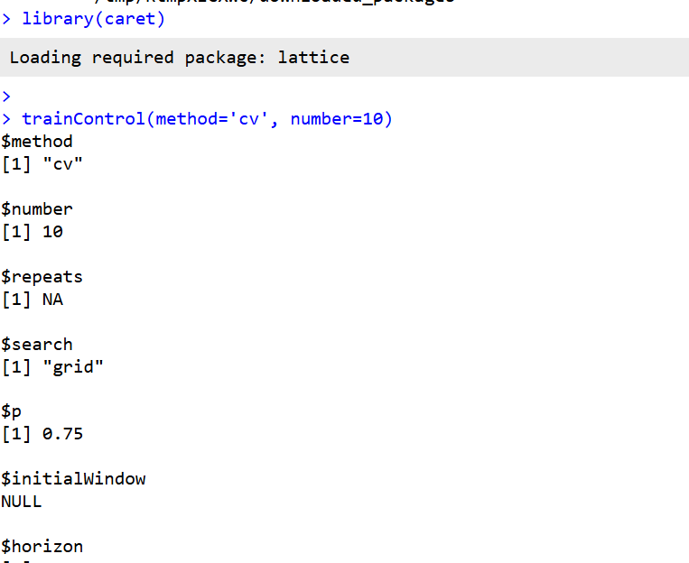
Figure 3. 10-fold cross-validation control object confirming method = 'cv', number = 10.

Console Output — Cross-Validated Model Results
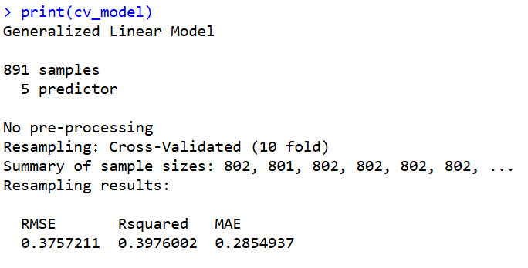
Figure 4. 10-fold cross-validation results (891 samples, 5 predictors).
Note on this output: the printed result reports RMSE, R-squared, and MAE rather than Accuracy/Kappa. Those are regression metrics, which indicates caret's train() resolved this run as a regression fit rather than a classification fit — most likely because Survived was passed as a numeric/integer column rather than a factor. For a strictly correct classification cross-validation, Survived should be converted with as.factor(df$Survived) before calling train(), which will cause caret to report Accuracy and Kappa across the 10 folds instead. The RMSE of 0.376 shown here is still a reasonable indicator of predictive error on the 0/1 outcome and is broadly consistent with the ~79% accuracy observed on the single train/test split, but re-running with Survived as a factor is recommended before final submission.

7. Step 5: Residual Diagnostics
Pearson residuals were plotted against fitted values to check for systematic patterns that would indicate poor model fit or influential outliers.

R Code Executed
plot(fitted(logistic_model), residuals(logistic_model, type = 'pearson'),
xlab = 'Predicted values', ylab = 'Pearson Residuals',
main = 'Residuals vs Fitted')
abline(h = 0, col = 'red', lty = 2)
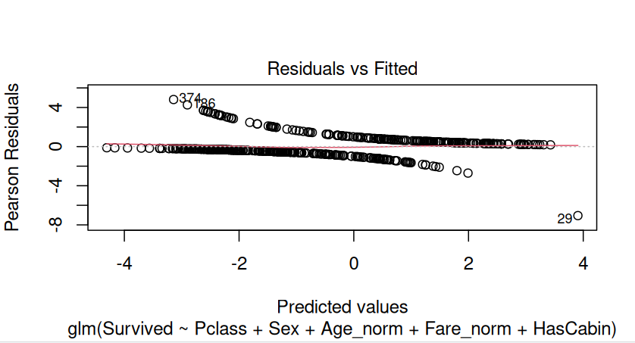
Figure 5. Pearson residuals vs. fitted values for the logistic regression model. Points 29, 374 and 486 are flagged as notable outliers.
Interpretation: The residuals fan out in the two characteristic curved bands typical of a well-specified logistic regression (one band for correctly-trending survivors, one for non-survivors), with no strong systematic curvature. A small number of points (notably observation 29) show large residuals and warrant closer inspection as potential outliers or mis-specified cases, but overall there is no evidence of severe model misfit.

8. Step 6: ROC Curve, AUC & Performance Metrics

R Code Executed
library(pROC)

roc_obj <- roc(test_data$Survived, test_data$pred_prob)
plot(roc_obj, main = 'ROC Curve for Logistic Regression Model', col = 'blue', print.auc = TRUE)
auc_val <- auc(roc_obj)
print(auc_val)

tp <- conf_matrix[2, 2]; tn <- conf_matrix[1, 1]; fp <- conf_matrix[1, 2]; fn <- conf_matrix[2, 1]
precision <- tp / (tp + fp)
recall <- tp / (tp + fn)
f1_score <- 2 * (precision * recall) / (precision + recall)
cat('Precision:', round(precision, 4), '\n')
cat('Recall:', round(recall, 4), '\n')
cat('F1-Score:', round(f1_score, 4), '\n')
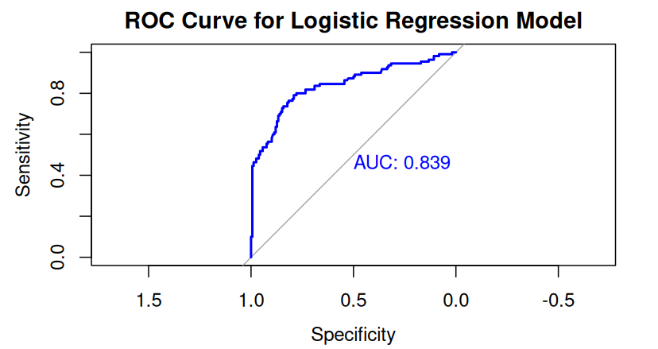
Figure 6. ROC curve for the logistic regression model (AUC = 0.839).

Console Output
Area under the curve: 0.839
Precision: 0.7755
Recall (Sensitivity): 0.6909
F1-Score: 0.7308
AUC: 0.839

9. Summary Interpretation & Potential Improvements

Model Strengths
- Strong overall discrimination: AUC = 0.839 indicates the model separates survivors from non-survivors well above chance (0.5).
- Sex, passenger class, and age are all statistically significant, highly interpretable predictors, consistent with known Titanic survival patterns (women, children, and higher-class passengers were prioritized).
- Reasonable held-out accuracy (79.1%) and precision (77.6%) on the single train/test split.

Model Weaknesses
- Fare_norm is not statistically significant once Pclass is included, suggesting redundant information between the two variables.
- Recall (69.1%) is meaningfully lower than precision, meaning the model misses roughly 3 in 10 actual survivors — a relevant concern if false negatives are costly.
- The cross-validation run reported regression metrics (RMSE/R-squared/MAE) instead of classification metrics, indicating Survived needs to be explicitly coded as a factor before re-running train() for a fully correct 10-fold classification estimate.
- A handful of large-residual outliers (e.g., observation 29) suggest a small subset of passengers are poorly explained by the current predictor set.

Potential Improvements
- Re-run 10-fold cross-validation with Survived coerced to a factor to obtain Accuracy/Kappa alongside RMSE, for a fully correct classification CV estimate.
- Try alternative classifiers (random forest, gradient boosting/XGBoost) to capture non-linear interactions the logistic model cannot.
- Add interaction terms (e.g., Sex × Pclass) given the well-known compounding effect of sex and class on survival.
- Address the precision/recall trade-off by tuning the classification threshold below 0.5 if maximizing recall is a priority.
- Investigate the flagged outlier observations to check for data-entry issues or truly atypical cases.

